Rotary Club of Renton

February 2021

Hello Renton School District High School Seniors,

Our club is pleased to offer eight $3,000.00 scholarships for the 2021-2022 school year. We will award a scholarship to two students from each of the four high schools in the Renton School District: Albert Talley Sr. High, Hazen High, Lindbergh High and Renton High. The Rotary Club of Renton is a service-oriented club dedicated to helping people in need locally and internationally, and thus service is an important criterium in our selection process.

Our criteria for selecting scholarship winners:

  - Ability to express oneself in writing, through the application essay, and in person for those who are invited to a personal interview.
  - Post-high school educational plans
  - Community involvement / volunteer work – (Rotary is a Service Club)
  - School involvement, extracurricular activities, clubs, and sports
  - Financial need
  - Strong academic achievement

You may access the application at each school’s Career Center’s website. Please download the electronic application, complete (Must be typed, no handwritten applications will be accepted), then print a hard-copy version of your application for submission. In addition to the completed application, you will need a copy of your official transcript from the Counseling Office, as well as three letters of recommendation (at least one must be from a teacher, the other two may come from different members of the community who are aware of your leadership and service qualities). Submit your completed application, along with your official transcript and the three letters of recommendation, to your Career Center Specialist.

Dates to remember:
Tuesday, March 16th Completed applications due to the Career Center
Tuesday, April 27th Finalists will be interviewed 3:00 - 7:00 PM
Thursday, May 27th Awards luncheon, Maplewood Golf Course 12:00-1:30 PM

Please note that, due to the large number of applications received, we are only able to consider Applications that have been completed using the online form and have all the attachments with them at the time of submission (official transcript and three letters of recommendation) No handwritten applications will be accepted and no additional documents will be reviewed.

On behalf of fellow Rotarians and the Scholarship Committee in particular, I extend to you best wishes for this scholarship process and much success in your educational pursuits.

Warm regards,
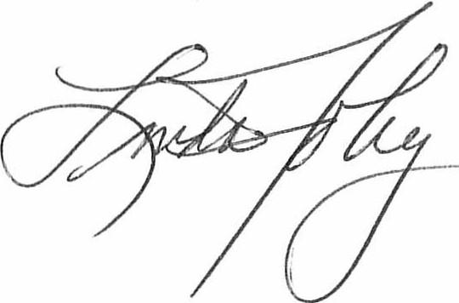

FoleyPresident, Rotar
Linda Foley, President Rotary Club of Renton
Seniors eligible for acceptance at an accredited college, university, or vocational post secondary program who wish to be considered for first year supplemental financing are encouraged to apply to the Renton Rotary Club Scholarship Committee by completing this form. Please exercise care in answering questions, as you are responsible for the validity of your answers. The Application has questions on four pages (use the space you need to complete) and there are three Guidance Sheets for you to print and give to the people you ask to write letters of recommendation for you.

Be sure to follow the application directions indicated on the previous page.

PERSONAL DATA

Full Name: ___________________________________________
Date: ______________
High School Name: _____________________
Telephone: ______________
Email: ____________
Address: _______________
City: _________________
Zip: _________________

- Number of years you have attended school in the Renton School District
- Accumulative Grade Point Average (G.P.A.). (grades 9 through 12):
Place an X in the appropriate box.
  - 2.5 – 3.0 GPA b. 3.1 – 3.5 GPA c. ____3.6 – 4.0 GPA

- What college/university do you plan to attend?

  - First Choice:
  - Second Choice:

- What are you considering for your college major or field of study? Discuss ways this choice may equip you to serve community.

ACTIVITIES – ACCOMPLISHMENTS – PERSONAL GROWTH

- List all the extra-curricular activities you were involved in during high school (in and outside of school):
- Name the activities specifically related to community service, beyond those listed above, in which you are participating/have participated.:
- List any awards or special achievements you earned during high school:
- Have you or your family faced any challenges that you have overcome, name them (you may elaborate more in your essay).

ESSAY

In at least 300 words, please describe:
- Your commitment to helping others, what you see as your gifts for service beyond self,
- Explain the ways you see your education equipping you to give back to your community in Renton or beyond, and
- Share with the committee qualities unique to you that reflect your capacity for leadership and your passion for improving our world through your personal attributes and the post-secondary education for which you are seeking a Renton Rotary Scholarship. .

(You may add an additional sheet, if you need space.)

FINANCIALS

- Tell us about your family situation as it relates to financial need including, but not limited to number of dependent children in the home, number of dependent children attending college next year, loss of employment, etc.

- Describe in detail how you plan to finance your education:

2020 RENTON ROTARY SCHOLARSHIP APPLICATION FORM

Recommendation for Rotary Scholarship

Applicant’s Name: _____________________________________
Please return your Letter of Recommendation for the student named above to him or her no later than Friday, March 5, 2021 so it may be included with the student’s scholarship application due by March 16, 2021.

Guidelines for Writing Letter of Recommendation:

Please indicate your relationship to student, teacher, counselor, neighbor, employer, fellow volunteer, etc.

Within your letter, comment on the applicant’s citizenship, what qualities do you see that suggest this student has a passion for service. You may also address scholastic ability, aptitude, accomplishments, and general characteristics. We are especially interested in your evaluation of the following behavioral traits, and any other characteristics you feel will help us in evaluating this student’s application:

- Understanding of Others in Addition to Self: Ability to perceive needs of others and help when appropriate; shows motivation, dependability, and resourcefulness to address work that needs to be done. Ability to be organized and lead others.

- Cooperation/Personality: Willingness to work within a team when appropriate, is able to contribute to the overall sense of purpose and belonging for all.

- Judgment: Responds in a fair way toward others. Shows the ability to gather information and use it in an unbiased way when called upon to make decisions, so all benefit.

